**Environmental monitoring**

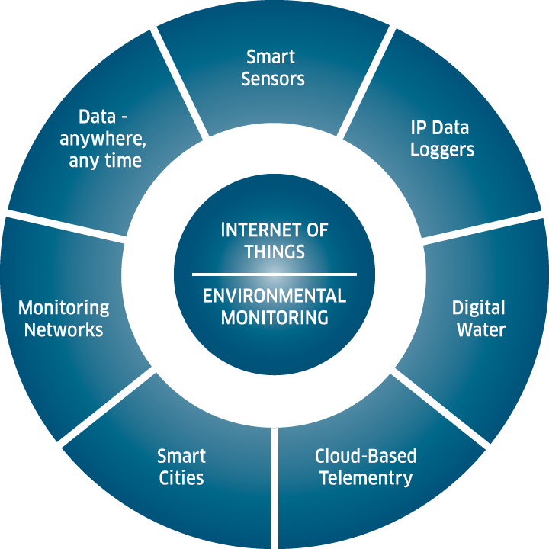

**Environmental monitoring involves the systematic collection and analysis of data to track and assess various aspects of the natural environment. This process helps in understanding and managing environmental conditions. Here's a basic definition and a design framework for environmental monitoring:**

**Definition:**

**Environmental monitoring is the process of continuously or periodically observing, measuring, and recording parameters and factors such as air quality, water quality, soil conditions, biodiversity, weather patterns, and more to evaluate the state and changes in the environment.**

**Design for Environmental Monitoring:**

**1. Objective Definition:**

**- Clearly define the purpose of the monitoring, whether it's for pollution control, ecological research, climate analysis, or other goals.**

**2. Selecting Parameters:**

**Identify the specific environmental parameters to monitor, such as temperature, humidity, pollutants, species populations, etc., based on the defined objectives.**

**3. Sensor Selection:**

**Choose appropriate sensors and data collection instruments for each parameter. Ensure they are accurate, reliable, and calibrated.**

**4. Data Collection Frequency:**

**Determine how often data will be collected. Continuous, real-time monitoring or periodic sampling may be necessary depending on the objectives.**

**5. Data Storage and Management:**

**Set up a system to store, organize, and manage the collected data, including a secure backup system.**

**6. Data Analysis:**

**Develop algorithms or analytical tools to process and interpret the data to extract meaningful insights.**

**7. Visualization:**

**Create graphical representations and reports to communicate the results to stakeholders effectively.**

**8. Location Selection:**

**- Identify strategic monitoring locations, considering geographical diversity and proximity to potential sources of environmental change.**

**9. Communication and Alerts:**

**Implement a system for real-time alerts or notifications in case of critical environmental changes or anomalies.**

**10. Regulatory Compliance:**

**- Ensure that the monitoring system complies with relevant environmental regulations and standards.**

**11. Integration of Remote Sensing and IoT:**

**Incorporate remote sensing technologies and IoT devices for broader coverage and more accurate data collection.**

**12. Data Sharing:**

**Consider sharing data with relevant government agencies, research institutions, or the public to promote transparency and collaboration.**

**13. Maintenance and Calibration:**

**Establish a regular maintenance schedule for sensors and instruments, including calibration and quality control procedures.**

**14. Cost Considerations:**

**Budget for equipment, personnel, and ongoing operational costs.**

**15. Adaptability and Scalability:**

**- Design the monitoring system to be adaptable to changing environmental conditions and scalable to accommodate future needs.**

**16. Ethical and Privacy Considerations:**

**Address ethical concerns related to data collection and privacy, especially when monitoring involves sensitive ecosystems or private property.**

**17. Feedback Loop:**

**Use the collected data to inform decision-making, policy changes, or environmental interventions as needed.**

**Innovation of Environmental monitoring**



Incorporating data visualization techniques to showcase historical temperature and humidity trends can be a powerful way to communicate insights and trends effectively. Here are some steps and visualization options to consider:

**1. Data Collection and Preparation:**

- Gather historical temperature and humidity data from reliable sources. You may use sources like weather stations, government agencies, or online databases.

- Organize the data into a structured format, typically in a spreadsheet, with columns for date, temperature, and humidity.

**2. Choose the Right Visualization Tool**s:

- Depending on your data and the story you want to tell, select the most suitable visualization tools. Common options include line charts, bar graphs, scatter plots, heatmaps, and more.

**3. Line Charts for Time Series Data:**

- Line charts are excellent for showing trends over time. You can create separate line charts for temperature and humidity with time (e.g., years or months) on the x-axis and temperature/humidity values on the y-axis.

- Highlight important events, such as extreme weather conditions or significant fluctuations, using annotations or markers on the chart.

**4. Heatmaps for Seasonal Trends:**

- Heatmaps are useful for visualizing seasonal patterns in temperature and humidity. You can use color gradients to represent the variations throughout the year.

- Group the data by months or seasons and display the heatmap, with each cell representing the average temperature or humidity for that period.

**5. Bar Graphs for Comparisons:**

- Bar graphs can be helpful when comparing temperature and humidity across different years, locations, or regions. You can create side-by-side bar charts or stacked bar charts to showcase these comparisons effectively.

**6.Scatter Plots for Correlations:**

- If you want to explore the relationship between temperature and humidity, consider using scatter plots. Each data point represents a specific date, with temperature on one axis and humidity on the other.

- You can also add regression lines to visualize any correlations.

**7. Interactive Visualizations:**

- If you are creating digital content, consider using interactive visualization tools or libraries like D3.js, Plotly, or Tableau. Interactive elements like tooltips, zooming, and filtering can enhance the user's experience and allow them to explore the data.

**8. Add Context and Annotations**:

- Ensure that your visualizations have clear labels, titles, and axis descriptions. Include annotations to highlight significant events, trends, or anomalies in the data.

- Provide context by adding background information, such as climate change statistics or historical events, that may have influenced temperature and humidity trends.

**9. Geographic Visualization Consider:**

- If your data includes information from different geographical locations, you can create geographic visualizations like maps or chloropleths to show regional variations in temperature and humidity.

**10. Accessibility and Responsiveness:**

- Ensure that your visualizations are accessible to all users, including those with disabilities. Use alt text for images and choose color schemes that are easy to read.

- Make sure your visualizations are responsive and can adapt to different screen sizes and devices.

**Development 1**

1. **Data Collection**: Collect the data from various sources, such as sensors, satellites, weather stations, or data providers. Ensure that the data is in a format that can be used for analysis. Common data formats include CSV, Excel, JSON, or specific environmental data formats like NetCDF.
2. **Data Cleaning**:
   * Handle missing values: Check for missing or erroneous data points and decide on a strategy for handling them, which can include imputation, removal, or interpolation.
   * Outlier detection: Identify and handle outliers that can skew your analysis. Outliers can be indicative of measurement errors or extreme events.
3. **Data Integration**: If your dataset is collected from multiple sources or contains various types of data (e.g., temperature, humidity, air quality, and location data), integrate them into a single dataset. Ensure that the data is properly synchronized and time-stamped if necessary.
4. **Data Transformation**:
   * Convert units: Ensure that all measurements are in a consistent unit system, for example, converting temperature from Fahrenheit to Celsius.
   * Aggregate data: Depending on your analysis goals, you may need to aggregate data into different time intervals (hourly, daily, monthly) to extract meaningful patterns.
   * Feature engineering: Create additional relevant features from the raw data. For example, you may calculate the daily average temperature or the maximum pollutant concentration over a specific period.
5. **Data Visualization**:
   * Generate visualizations to explore the dataset and identify trends, anomalies, and correlations. Data visualization tools like Matplotlib, Seaborn, or Plotly can be helpful in this step.
   * Plot time series data to observe temporal patterns, and create spatial plots for geographic data.
6. **Data Splitting**:
   * If you plan to build predictive models, split your dataset into training, validation, and test sets. This is crucial to assess the model's performance.
7. **Data Normalization/Standardization**:
   * Depending on the modeling techniques you plan to use, you may need to normalize or standardize the data to ensure that all features have the same scale.
8. **Feature Selection**:
   * Identify and select the most relevant features for your analysis. This step can help improve the efficiency and interpretability of your models.
9. **Data Storage**:
   * Save the preprocessed data in a format that is easy to work with, such as CSV, HDF5, or a database. This allows you to access the data for further analysis without repeating the preprocessing steps.
10. **Quality Control**:
    * Implement a quality control process to ensure that your data remains accurate and representative. This may involve regular data validation and maintenance.
11. **Documentation**:
    * Document the preprocessing steps, data sources, and any assumptions made during the process. Good documentation is essential for reproducibility and collaboration.

Remember that the specific preprocessing steps will depend on the nature of your environmental monitoring data, the goals of your analysis, and any domain-specific requirements. Additionally, you may need to revisit and update your preprocessing pipeline as new data becomes available or as your analysis goals evolve.

Loading and preprocessing a dataset for environmental monitoring involves several steps to ensure the data is ready for analysis and modeling. These steps may vary depending on the specific dataset and the goals of your analysis, but here is a general outline of the process:

1. **Data Collection**: Collect the data from various sources, such as sensors, satellites, weather stations, or data providers. Ensure that the data is in a format that can be used for analysis. Common data formats include CSV, Excel, JSON, or specific environmental data formats like NetCDF.
2. **Data Cleaning**:
   * Handle missing values: Check for missing or erroneous data points and decide on a strategy for handling them, which can include imputation, removal, or interpolation.
   * Outlier detection: Identify and handle outliers that can skew your analysis. Outliers can be indicative of measurement errors or extreme events.
3. **Data Integration**: If your dataset is collected from multiple sources or contains various types of data (e.g., temperature, humidity, air quality, and location data), integrate them into a single dataset. Ensure that the data is properly synchronized and time-stamped if necessary.
4. **Data Transformation**:
   * Convert units: Ensure that all measurements are in a consistent unit system, for example, converting temperature from Fahrenheit to Celsius.
   * Aggregate data: Depending on your analysis goals, you may need to aggregate data into different time intervals (hourly, daily, monthly) to extract meaningful patterns.
   * Feature engineering: Create additional relevant features from the raw data. For example, you may calculate the daily average temperature or the maximum pollutant concentration over a specific period.
5. **Data Visualization**:
   * Generate visualizations to explore the dataset and identify trends, anomalies, and correlations. Data visualization tools like Matplotlib, Seaborn, or Plotly can be helpful in this step.
   * Plot time series data to observe temporal patterns, and create spatial plots for geographic data.
6. **Data Splitting**:
   * If you plan to build predictive models, split your dataset into training, validation, and test sets. This is crucial to assess the model's performance.
7. **Data Normalization/Standardization**:
   * Depending on the modeling techniques you plan to use, you may need to normalize or standardize the data to ensure that all features have the same scale.
8. **Feature Selection**:
   * Identify and select the most relevant features for your analysis. This step can help improve the efficiency and interpretability of your models.
9. **Data Storage**:
   * Save the preprocessed data in a format that is easy to work with, such as CSV, HDF5, or a database. This allows you to access the data for further analysis without repeating the preprocessing steps.
10. **Quality Control**:
    * Implement a quality control process to ensure that your data remains accurate and representative. This may involve regular data validation and maintenance.
11. **Documentation**:

Document the preprocessing steps, data sources, and any assumptions made during the process. Good documentation is essential for reproducibility and collaboration

**Development 2**

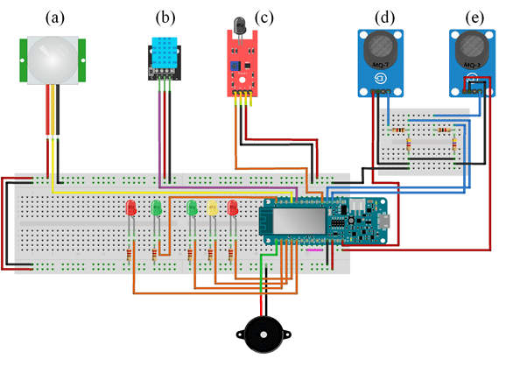

**Python Coding**

import serial

# Connect to the serial port where the sensor is connected

ser = serial.Serial("/dev/ttyUSB0", 9600)

# Read the sensor data

data = ser.readline()

# Parse the sensor data

temperature = float(data.split()[0])

humidity = float(data.split()[1])

# Print the sensor data to the console

print("Temperature:", temperature)

print("Humidity:", humidity)

import board

import busio

import adafruit_bme280

# Create a BME280 sensor object

bme280 = adafruit_bme280.BME280(board.I2C())

# Read the temperature and humidity from the sensor

temperature = bme280.temperature

humidity = bme280.relative_humidity

# Print the sensor data to the console

print("Temperature:", temperature)

print("Humidity:", humidity)

* Sensors: Sensors are used to collect data on various environmental parameters, such as air quality, water quality, and soil quality. Sensors can be deployed in a variety of locations, including fixed stations, mobile platforms, and even wearable devices.
* Data communication and storage: Once the data is collected by sensors, it needs to be transmitted to a central location for storage and analysis. This can be done using a variety of communication technologies, such as cellular networks, Wi-Fi, and satellite links. The data is then stored in a database for further analysis and reporting.
* Data analysis and visualization: The data collected by the sensors is analyzed to identify trends and patterns. This information can then be used to make informed decisions about environmental management. Data visualization tools are used to present the data in a clear and concise way, making it easier to understand and interpret.

Future engineering for environmental monitoring is focused on developing new and innovative technologies to improve the efficiency and accuracy of environmental monitoring. Some of the key areas of research include:

* Development of new sensors: New sensors are being developed that are more sensitive, selective, and durable than existing sensors. This will allow for more accurate and reliable monitoring of a wider range of environmental parameters.
* Deployment of sensor networks: Sensor networks are being deployed to collect data from a wider range of locations and at a higher frequency. This will provide a more comprehensive and real-time picture of the environment.
* Development of new data analytics tools: New data analytics tools are being developed to extract more insights from the large amounts of data collected by sensor networks. This information can then be used to make better decisions about environmental management.

**Future engineering for environmental monitoring**:

* Development of low-cost, wearable sensors: Low-cost, wearable sensors could be used to monitor people's exposure to pollutants and other environmental hazards. This data could then be used to identify areas of high risk and develop strategies to reduce exposure.
* Deployment of drone-based sensors: Drone-based sensors could be used to monitor remote areas that are difficult to access using traditional monitoring methods. This data could be used to track the spread of wildfires, monitor air quality, and assess the impact of natural disasters.
* Development of artificial intelligence (AI)-powered data analytics tools: AI-powered data analytics tools could be used to identify patterns and trends in environmental data that would be difficult to detect using traditional methods. This information could then be used to predict future events, such as air pollution spikes or water quality problems.